# Create Table

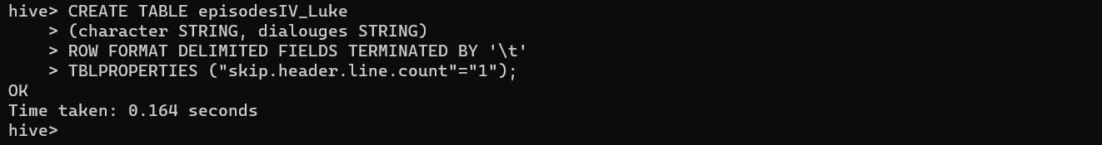

# Load File in table

LOAD DATA LOCAL INPATH '/episodeIV_dialouges.txt' INTO TABLE episodesIV_Luke;



# Exports to HDFS directory

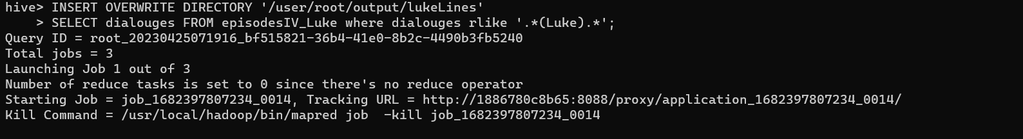

Job End:

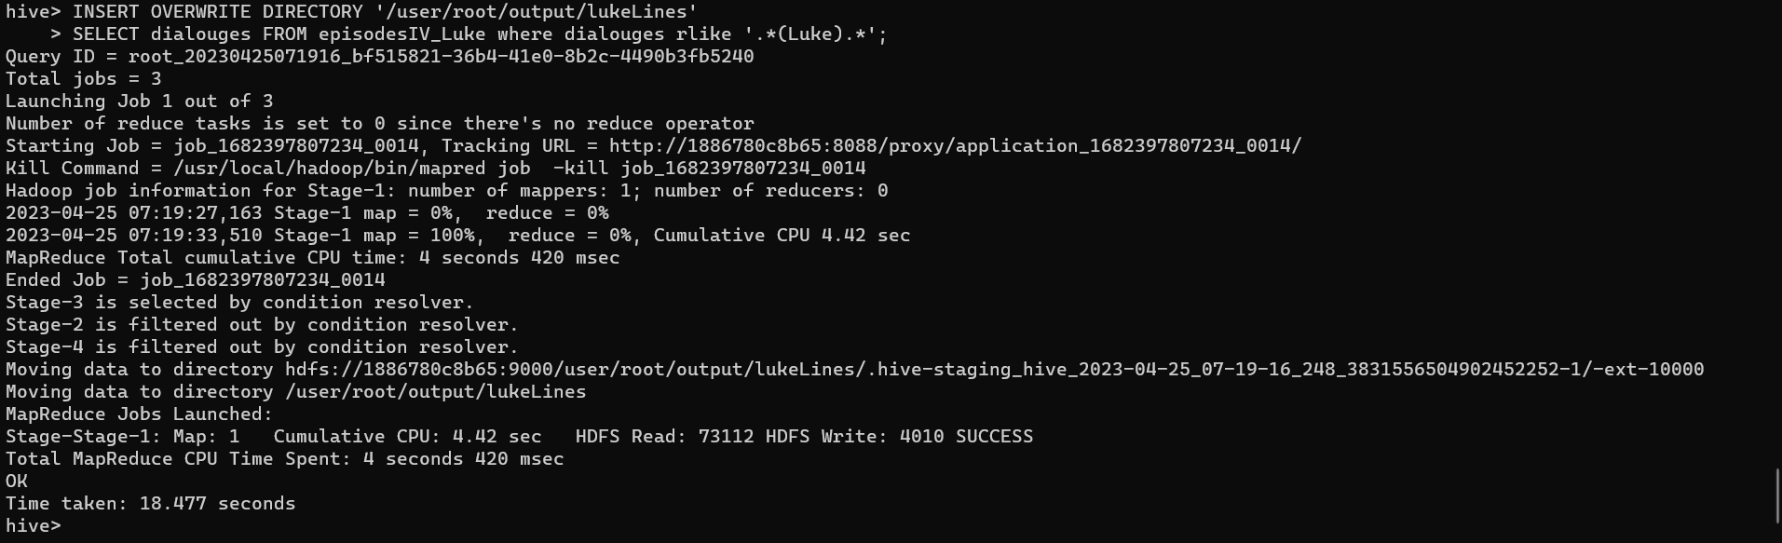

Results:

Output stored at Hdfs :

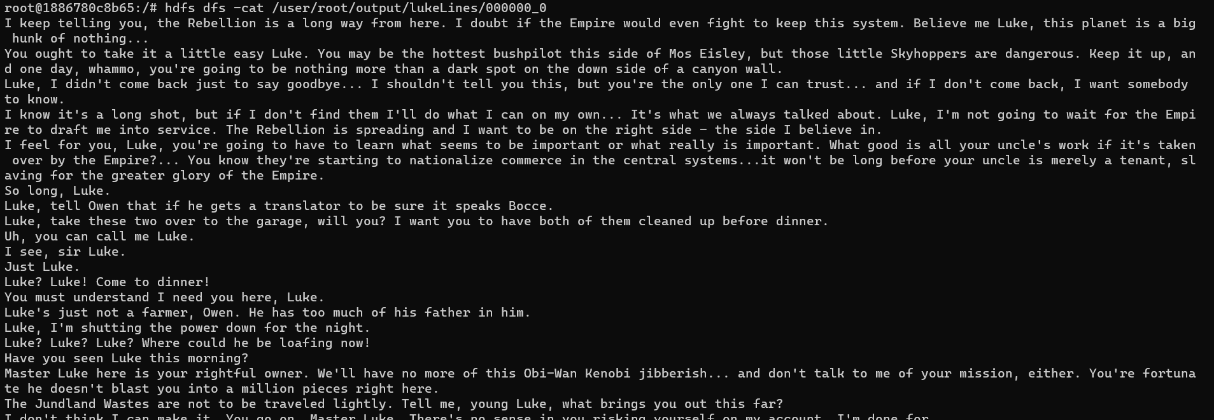

#check results in local

hdfs dfs -get /user/root/output/lukeLines/000000_0 /episodeIV/lukeLines

cat /episodeIV/lukeLines /000000_0

Episode 4 line results with Luke local

